“10 for 10” Staff Wellness Incentive
Begins March 2016

(available to staff working at least 20 hours per week)
This program encourages you to take a few minutes in your work day for yourself! We tend to stay in for lunch, eat where we work, etc. I think it is important to “Take 10” away from work to reconnect with nature, coffee, or, you pick!
When you take a 10 minute break (only one per shift please), you may enter a ticket (up to 10) for a monthly drawing. You must leave your desk and/or the building (tell someone too!) to qualify. By announcing your “10”, you will encourage your co-workers to follow your example!!
Please see Leann for your “10 for 10” tickets as you earn them!!
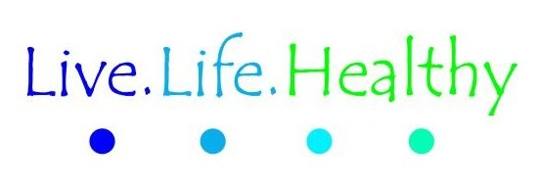

Examples of prizes (All in the amount of $10):
Gas card
Hardware store card
Local restaurant card
Cash
Gift certificate to local resale store
One “try it” exercise session through city park and rec (usually between $7-10)

